# Lesson 16 单词讲解

1. park n. 公园

v. 停放（汽车）

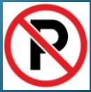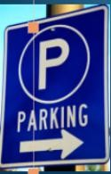Don’t park your car here. “No Parking” areas parking signs

1. traffic n. 交通traffic police traffic lights traffic accidents traffic jam / block heavy traffic

data traffic

1. 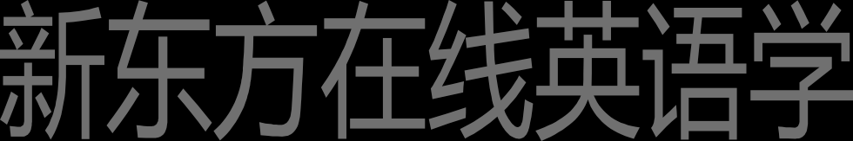reminder n. 提示，提示物

Rings are reminders of love.

remind v. 提醒remind sb. to do sth. remind sb. of sth.

I needn’t remind you of that terrible tie…

1. fail v. 失败，无视，忘记

fail in the exam

fail to do sth.

She failed to keep her word.

1. obey v. 服从，遵守

obey the rules

ticket

area n. 地段   
can't fail to do 不会不做……   
fail v. 忘记，无视   
note n. 便条   
obey v. 服从

# Lesson 16 课文&语法讲解

本课重点:

if 真实条件句假设将来

If + 句子 A， 句子 B

“如果 A， 那么就 B

if 条件状语从句 主句

if 条件状语从句 分两种： 真实条件句

非真实条件句 （虚拟语气）

if 真实条件状语从句

If tall chimneys were built above sea level, the tunnel would be well-ventilated. 【假设过去】

If she is sleeping, I will call her later. 【假设现在】

If it will rain tomorrow, we will stay at home. X

If it rains tomorrow, we will stay at home. 【假设将来】

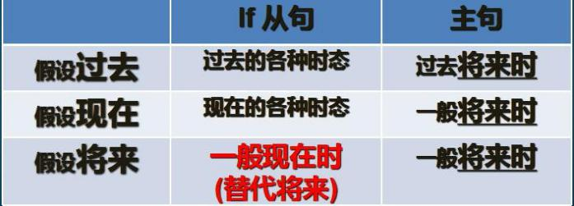If 真实条件句 时态

if 真实条件状语从句 【假设将来】

I shall see him, if he is (be) here next week.

If he _plays (play) well, he will get into the school team.

If they have (have) time the day after tomorrow, they will fly (fly) to London to have a meeting with us.

if 真实条件状语从句 【假设将来】

If you make (make) a mistake, correct it. If you like (like) him, you may tell him.

If she enjoys (enjoy) concerts, why doesn’t she come with us?

If you park your car in the wrong place, a traffic policeman will soon find it. You will be very lucky if he lets you go without a ticket.

Traffic police are sometimes very polite. a policeman - policemen

You will enjoy your stay here if you pay attention to our street signs.

If you receive a request like this, you cannot fail to obey it!

本课重点:

if 真实条件句假设将来

# Lesson 16 知识拓展

本课重点:

if 真实条件句

（假设将来）

if 真实条件句

如果他不在家，我就晚点再打给他。

If he is not at home, I will call him again later. if 真实条件句

如果你在工作，那我就不打扰你了。

If you are working, I will not bother you. if 真实条件句

如果明天下雨，我们就不出去了。

If it rains tomorrow, we will not go out. if 真实条件句

你会错过飞机的，如果你不快一点。

You will miss the plane if you don’t hurry up.